I hereby authorize Out Stretched Hands Counseling Center (OSHCC), its affiliates, subsidiaries and related entities to (select A and/or B):
B. Release/Disclose Information from my Out Stretched Hands Counseling Center (OSHCC) record to:

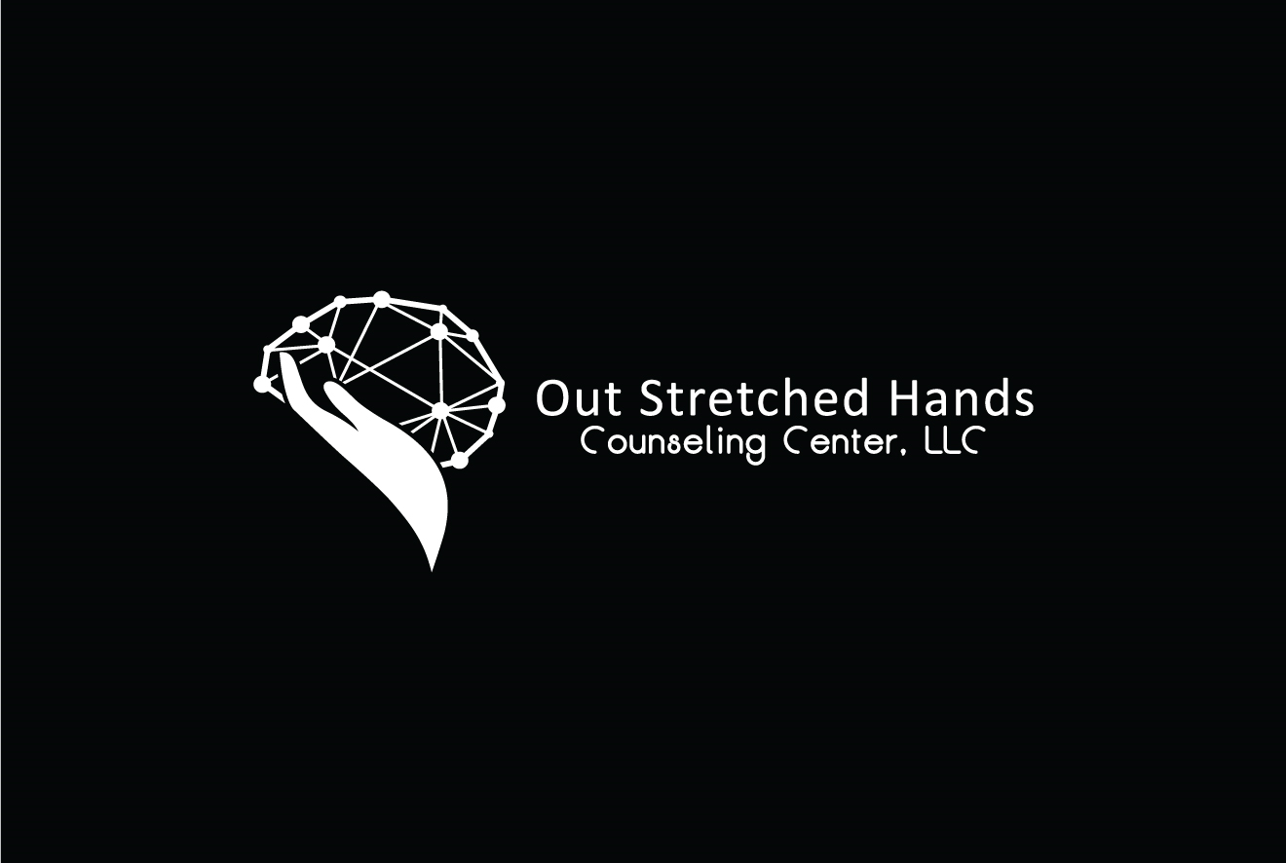
AUTHORIZATION FOR RELEASE OF INFORMATION
Consumer Name:
Parent, Guardian or Authorized Representative (If Applicable):
A. Request information from:
Individual/Organization Name:
Street Address:
City/State/Zip:
Telephone:
Email:
Individual/Organization Name:
Street Address:
City/State/Zip:
Telephone:
Email:
RECORDS TO BE RELEASED:
Assessment/ISP
Treatment Progress Report/USP
Treatment Plan/Home Study
Substance Abuse
Mental Health Treatment Records
Psychiatric Evaluation and Services
Evaluation/Treatment
Treatment Recommendations
Other (Describe):
Specific Description of requested documents:
FOR THE PURPOSE OF:
Continuity of Care
Reimbursement/Claims Processing
Case Management
Other (Describe):
IN THE FOLLOWING FORMAT:
Verbal
Written (Photocopy)
Electronic (CD, Jump Drive, Email)

Upon my written request, Out Stretched Hands Counseling Center (OSHCC) must provide me a record of any subsequent disclosures made for
to other parties.

Video/Photograph (this is not a media release)
Other:
RELEASE OF HIV/AIDS, SUBSTANCE ABUSE & MENTAL HEALTH RECORDS
Yes, I authorize the release of any records regarding the diagnosis or treatment of HIV/AIDS or other sexually transmitted disease.
Initial
Yes, I authorize the release of any records regarding drug, alcohol, mental health, or psychiatric treatment.
Initial
SIGNATURE
I understand that:
• My information cannot be disclosed without my written informed consent unless otherwise provided by law.
I have the right to revoke this authorization in writing at any time except to the extent that action has been taken in
reliance upon it.
I have a right to receive a copy of this authorization form.
legal, administrative or quality assurance purposes.
•
OSHCC is not liable or responsible for information that I authorize OSHCC to release
•
I am not required to sign this authorization. OSHCC will not restrict or limit services if I refuse to sign. A true and exact photocopy/faxed copy of this authorization shall have the same effect as the original.
Please check one of the two options below:
Unless I revoke this consent earlier, this consent will automatically expire 365 days after it is signed.
This consent is for a one-time release ONLY.
Signature of consumer, parent, guardian or authorized representative
Date of Birth
Date of Signature
STOP! Use this section ONLY if the consumer chooses to revoke this consent
This Authorization of Release of Records or Information has been revoked on:
Consumer/representative signature
Staff signature and credentials (if revocation given verbally)
NOTICE TO RECIPIENT OF INFORMATION
If the disclosure involves substance abuse treatment records, they are protected by Federal Confidentiality Rules, 42 CFR Part 2. Federal Rules prohibit further disclosure of this information unless further disclosure is expressly permitted by the written consent of the person to whom it pertains or as otherwise permitted by 42 CFR Part 2. A general authorization for the release of medical or other information is NOT sufficient for this purpose. The Federal Rules restrict any use of the information to criminally investigate or prosecute any alcohol or drug abuse patient

