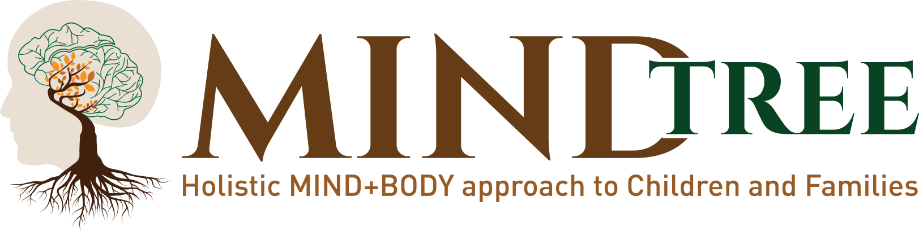

5440 SW Westgate Dr, #210 Portland OR 97221

www.MindTreeHolisticCounseling.com

Phone: 503-966-1556 ext. 1

Fax: 503-716-4699

Referral Form

Thank you for the referral to Mindtree! Our health care team specializes in providing Holistic Mind-Body counseling and wellness services for children, individuals, couples, and families. Our scheduling team will reach the patient/family for an individualized holistic treatment plan.

Client Information

Client Name:

Street Address: Town/ZIP: Telephone:

Is the Client aware of this referral? ☐Yes ☐No

Referral Source Information

Practice Name:
Name of Health Care Professional: |  |  | Doctor’s Telephone:

Practice Address:

Name of Person Sending this Referral:

Type of Service Requested (check all that apply)
☐ Mental Health  □ Play Therapy  □ Trauma Psychotherapy  □ Individual Counseling  (□ Adult / □ Child )  □ Eating Disorder  □ Perinatal / Post-Partum Therapy  □ Couples Counseling  □ Sex Therapy  □ EMDR | ☐ Classes/Support Groups  □ Yoga & Mindfulness Group Class or Private Sessions  □ Reiki Energy Healing Community Clinic  □ Hypnotherapy | ☐ Nutrition and Wellness  □ Nutrition Counseling  □ Ayurvedic Psychology  □ Ayurvedic Nutrition & Lifestyle Coaching | ☐ Body Work  □ Reiki for Children & Adults

Referral Comment Information

Referral Comments:

Email: info@mindtreeholisticcounseling.com

Phone: 503-66-1556 ext. 1 | Fax: 503-716-4699

